INDIA

Creating sid_india table.

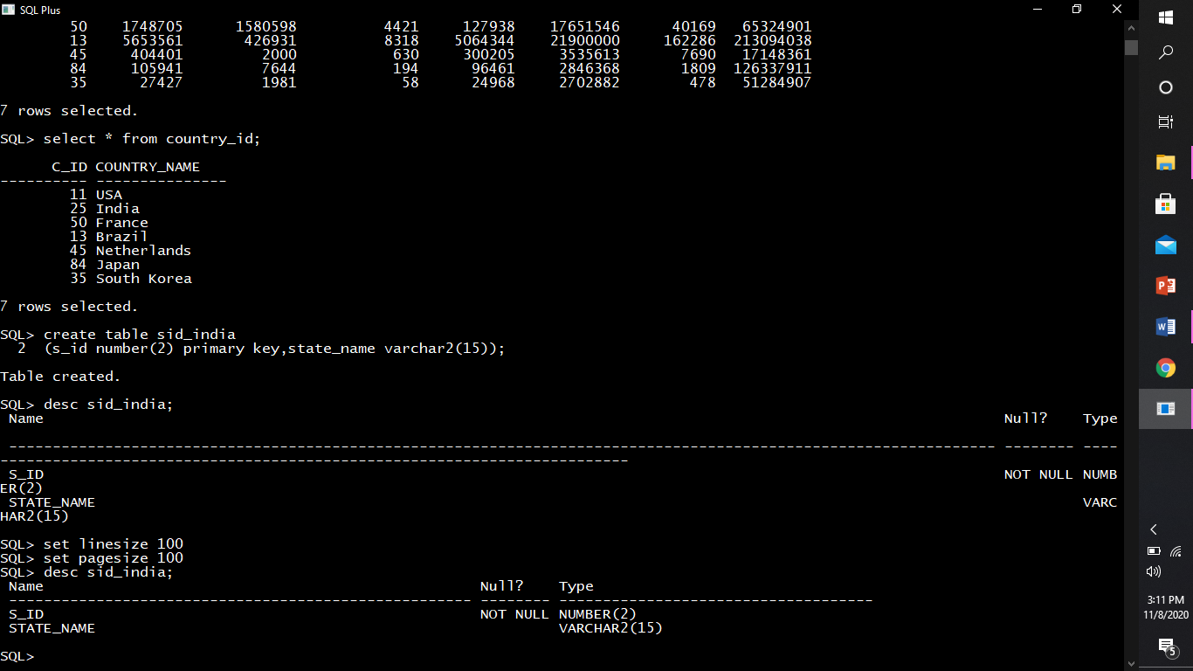

Describing structure of sid_india.



Inserting rows into sid_india.

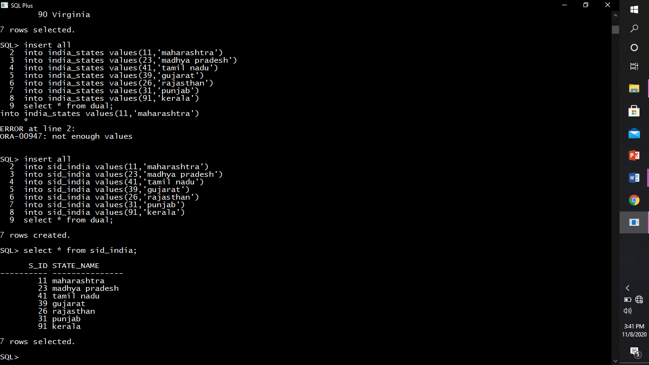

Creating table india_states.

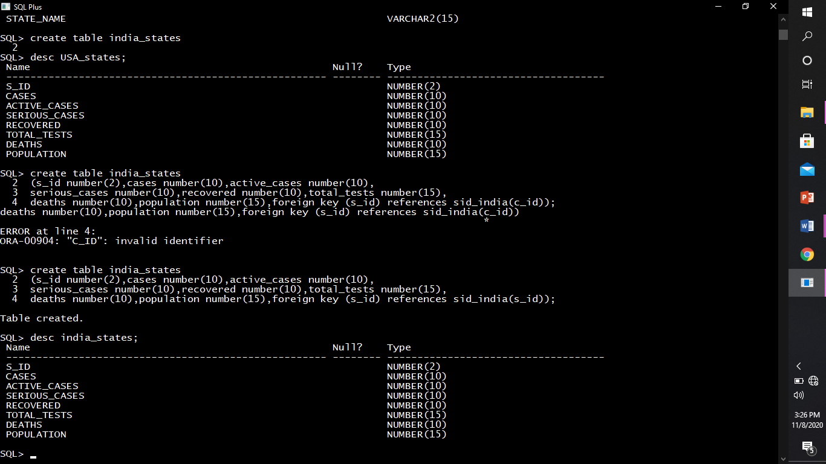

Describing structure of india_states.



Inserting rows into india_states.

